Read Me File

Start with the indexfile . It will show the initial page for the site and then you can click on any of the links in the nav bar to move to the next pages.

Create a database called c1_db

1. Our First Page is Home page: localhost/coffeeshop/index.php

2. Our Second page is Menu Page: localhost/coffeeshop/menu.html

3. Our Third Page is Store Page: localhost/coffeeshop/phpsqlsearch_map.html to view the store location

for this :

create a table : CREATE TABLE `markers4` (

`id` INT NOT NULL AUTO_INCREMENT PRIMARY KEY ,

`name` VARCHAR( 60 ) NOT NULL ,

`address` VARCHAR( 80 ) NOT NULL ,

`lat` FLOAT( 10, 6 ) NOT NULL ,

`lng` FLOAT( 10, 6 ) NOT NULL

)

and insert records.

INSERT INTO `markers4` (`name`, `address`, `lat`, `lng`) VALUES ('Frankie Johnnie & Luigo Too','939 W El Camino Real, Mountain View, CA','37.386339','-122.085823');

INSERT INTO `markers4` (`name`, `address`, `lat`, `lng`) VALUES ('Amici\'s East Coast Pizzeria','790 Castro St, Mountain View, CA','37.38714','-122.083235');

INSERT INTO `markers4` (`name`, `address`, `lat`, `lng`) VALUES ('Kapp\'s Pizza Bar & Grill','191 Castro St, Mountain View, CA','37.393885','-122.078916');

INSERT INTO `markers4` (`name`, `address`, `lat`, `lng`) VALUES ('Round Table Pizza: Mountain View','570 N Shoreline Blvd, Mountain View, CA','37.402653','-122.079354');

INSERT INTO `markers4` (`name`, `address`, `lat`, `lng`) VALUES ('Tony & Alba\'s Pizza & Pasta','619 Escuela Ave, Mountain View, CA','37.394011','-122.095528');

INSERT INTO `markers4` (`name`, `address`, `lat`, `lng`) VALUES ('Oregano\'s Wood-Fired Pizza','4546 El Camino Real, Los Altos, CA','37.401724','-122.114646');

4. Our Fourth page is Shop online page: localhost/coffeeshop/shoponline.php

create a table products

CREATE TABLE `products` (

`id` INT NOT NULL AUTO_INCREMENT PRIMARY KEY ,

`product_code` VARCHAR( 60 ) NOT NULL ,

`product_name` VARCHAR( 80 ) NOT NULL ,

`product_desc` VARCHAR( 60 ) NOT NULL ,

`product_img_name` VARCHAR( 60 ) NOT NULL,

'price` DECIMAL( 10, 2 ) NOT NULL

)

Insert records in the products table. This data will be shown in the products page.

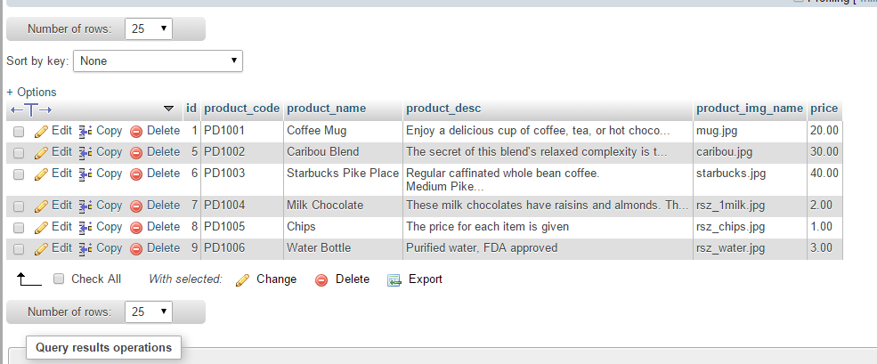

5. Our Fourth page is login: It will not allow to login if you are not registered

6. Our fifth page is Register: For registration create a user table in database

CREATE TABLE `users` (

`user_id` INT NOT NULL AUTO_INCREMENT PRIMARY KEY ,

`username` VARCHAR( 60 ) NOT NULL ,

`email` VARCHAR( 80 ) NOT NULL ,

`password` VARCHAR( 60 ) NOT NULL ,

)